|  |  |  |
| --- | --- | --- |
| Advanced Software Engineering Group 4 | October 19  2012 | |
| Project Plan | |  |

Signed Off By:

Sean Chapman: Candidate Number: 102223

Jolanta Rusecka: Candidate Number: 102150

Chris Walker: Candidate Number: 102227

[Andria Orphanidou](https://plus.google.com/u/0/101226752234022848438?prsrc=4): Candidate Number: 102148

Ewen Cluley: Candidate Number: 102230

Contents

Document purpose 2

Project Outline 2

Project approach 3

Project schedule 5

Stakeholders and communication 6

Conflict Resolution Plan 7

General Practice: 7

Code of Practice: 7

Emergency Group Meeting Policy: 7

Common Tactical Policies 9

Peer assessment plan. 11

Appendices 13

# Document purpose

The purpose of this document is to:

|  |  |
| --- | --- |
| * Introduce the project along with the goals and deliverables. * Outline the management and development approach for the project * To outline the project organisation * To provide an initial schedule for the project. * To provide common tactical policies for use in the project. * To outline the approaches to configuration management, conflict resolution and risk management. * Any constraints assumptions and risks that may impact the scope, timeliness or quality of the project.   As this project evolves over its life cycle, this document will be changed accordingly and any modifications will be recorded in the change log. |  |

# Project Outline

Main Aim:

The main aim of the project is to develop an application for the android operating system. Initially this application will display the time and GPS location of the device the application is installed on. The requirements for this application are subject to change over time and as such if the requirements change the application will be modified to meet the revised requirements.

Measures of effectiveness:

We shall measure the effectiveness and success of the of the project and application development by using the following:

* Using appropriate tests (both black and white box) on the application.
* Product owner review of the final application.
* Creating end user surveys and testing groups.
* Creating prototypes and surveying testing groups with the prototypes.
* Using a peer marking scheme to assess member performance within the team.
* Generate reports and documentation for each aspect of the project.
* Each member writing a personal reflection of the project process as a whole including an end to end process review.

# Project approach

The approach we shall be taking for the purpose of the project is an Agile Software Engineering methods. It will be feature and test driven development with a small, feedback driven team which will be able to adapt to changes in requirements as and when these changes happen. Individuals a

The team will make use of several types of UML diagrams as and when it will be appropriate and also benefit the development of the project. Such diagrams may include but are not limited to:

* Use case diagrams
* Data flow diagrams
* Sequence diagrams
* Class diagrams

The team will also make use of a product backlog which will store user requirements of the application in development. These requirements will be stored in order of priority. A product breakdown structure (PBS) may be produced in order to compliment the listed items in the log and visually represents products required to build the application.

A Gantt chart will also be produced which will be used to track the team’s progress. This will be used initially to allocate resources (members of the team) to a given task. It will also be used in order to re-allocate work based on priority of tasks should the need arise (See conflict resolution plan).

The team will work on the project in terms of sprints. Each sprint will last for 7 days and run from Thursday to Thursday. During each sprint a set of tasks will be completed by each member of the team in order for the progress of the project to continue on schedule. At the beginning of each sprint a group meeting will be held to discuss tasks completed on the previous sprint and allocate new tasks for the upcoming sprint. Also at the beginning of each sprint a weekly meeting will take place between the team and the product owner (the customer) to present the work completed in the previous sprint and to also receive any additional information which is important to the project e.g. new/change in requirements, design and functionality considerations etc. At the end of each sprint a test group will be presented with the latest version of the application and participate in user testing in order to identify an areas which have failed or exceeded expectations. This will also help ensure quality control of the final product.

The team may be required to have meetings on a more regular basis than the weekly sprint meetings. Any additional meetings that take place will be recorded along with their agenda’s and minutes.

Quality control throughout the project will be kept in place by using the following procedures:

* As each member of the team submits a piece of work, it shall be check by at least 1 other member of the team. If anything is in doubt the team will discuss the work at the earliest possible opportunity.
* The project will be test and feature driven, this will enable each feature to be tested as it is created to ensure there are no bugs in the software.
* The customer will be consulted throughout the project to ensure the project meets with the customers standards.

Configuration management will be in place throughout the project. The team will be using GitHub to store and sync files. This tool has been selected as it contains version control as standard and allows any role back should the user requirements change and a feature have to be removed from the project.

# Project schedule

The following Gantt chart and table show the current project schedule including when each sprint is due to start and finish. As each set of tasks is completed within a sprint, individual tasks have been omitted from this diagram as it is not currently clear what specific tasks will be present during the project however it is clear how many sprints there will be.

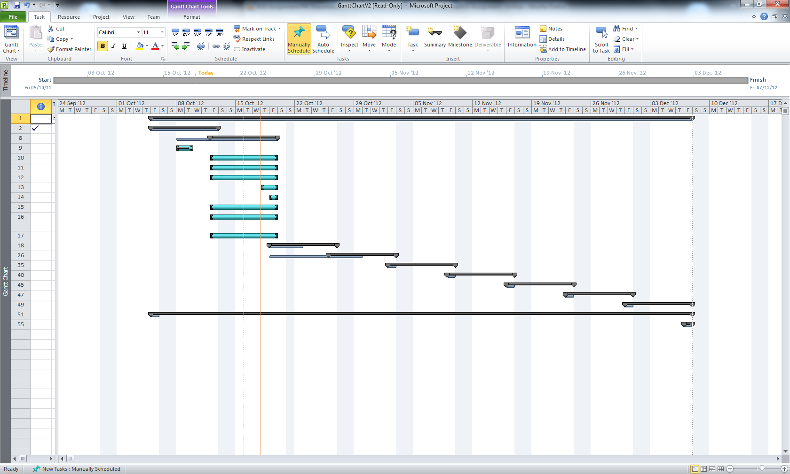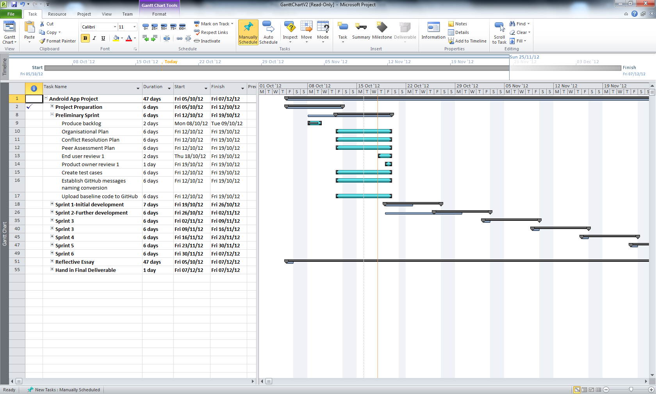

# Stakeholders and communication

The following table shows the communication methods with the stakeholders within the project as well as their frequency.

|  |  |  |  |
| --- | --- | --- | --- |
| Stakeholder | Stakeholder Type | Communication path | Frequency |
| Project team  members | Internal | Team meetings,  team forum,  e-mails, phone, GitHub | At least 1 per week  Ad hoc , whenever required |
| Product owner | External | Meetings & reviews,  e-mails,  Survey | Weekly  Ad hoc , whenever required |
| End users | External | Product reviews  E-mails,  Survey | Weekly  Ad hoc, whenever required |

# Conflict Resolution Plan

This conflict resolution plan must be adhered to when conflicts arise within the group.

## General Practice:

These stages are to be used in relation to any conflict that arises:

* Stage 1: Attempt to solve the conflict with the person who the conflict has arisen with.
* Stage 2: Fill in the conflict declaration form and submit it to the group manager. If the manager is involved with the conflict then submit the conflict declaration form to an impartial mediator from the group. The manager/mediator will then attempt to solve the conflict, recording the steps taken and solution on the conflict solution form.
* Stage 3: If the conflict cannot be resolved by the manager/mediator, an emergency meeting will be called immediately to which as many of the group as possible must attend. If the conflict is solved by the group, then a conflict solution form must be filled in as stated in stage 2.
* Stage 4: If the conflict cannot be solved by the group, then the group will seek the advice of the Lecturer or a Teaching Assistant to help aid in the conflict resolution.

## Code of Practice:

The following is a code of practice that will be undertaken in order to avoid conflicts arising:

* Each group member must document everything that they do towards the project, this is to help prevent disagreements arising between members in regards to contribution of work.
* At each meeting it will be recorded in the minutes what each member of the group task(s) will be during the current sprint to prevent members disagreeing about who is supposed to be completing each task.
* If work is going to be late, let the group know as soon as possible and if necessary help will be given in order for the work to be completed as soon as possible. See emergency group meeting policy below.
* All documents will adhere to a single format in order to maintain consistency.
* Be helpful and considerate of other group members, treat everyone with respect at all times.

## Emergency Group Meeting Policy:

If any of the following circumstances occur an emergency group meeting must be held:

* Progress is running consistently behind schedule after 2 sprints
* Work is consistency completed late by a member(s) of the group
* A group member drops-out
* A group member is unavailable to work either on a short or long term basis e.g. through illness, injury or personal situation/problems.
* Stage 3 is reached in conflict resolution plan

Any emergency meeting that is called must be attended by as many as the group as possible and minutes will be taken of the meeting.  
  
In general an emergency meeting will be called due to either conflict or for re-distribution of work.

* In the case of a conflict the group will attempt to mediate the conflict that has arisen and if no agreement can be reached through discussion a vote will be taken in order to solve the problem. If the result of the vote does not solve the conflict then stage 4 of the conflict resolution plan will used.
* In the case of the re-distribution of work the group will meet and discuss how the work can be re-distributed. If the work is unable to be re-distributed then in the meeting the group will discuss whether re-negotiating the work to be delivered with the Customer would be possible and if so decide upon what the group would want the outcome of the negotiations with the customer to be, after which the group will approach the customer in an attempt to re-negotiate the work to be completed.

# Common Tactical Policies

The team will make use of several common tactical policies which will adhere to agile methodology and approaches. These policies will fall under the sub-categories depending on what the policy is and how it affects the group and must be adhered to at all times. The sub-categories are:

* Communication
* Work Assignment
* Submission of Work
* Change of Requirements over time.
* Peer Assessment
* Conflict Resolution

As follows are the policies that will be enforced for each of the sub-categories:

**Communication:**

Policy 1: All communication regarding work which is sent by email will be copied to all members of the team, this is so that all members of the team can keep track of work progress that is being made and if no progress is being made or there is no communication for long periods of time it will give the team time to intervene and steps to be taken to ensure smooth progress of work.

Policy 2: If a team member is struggling with work load or believes they are unable to complete the work assigned then a communication will be sent to all members of the group so steps can be taken to help the team member.

Policy 3: Communication will take place in the form of text messages, emails and use of the forum. Phone calls will only be used as a last resort if communication with a team member cannot be made.

Policy 4: Weekly team meetings will be attended by each member of the group. If a team member is aware they will not be at a meeting then they must communicate this with the group and it will also be recorded in the minutes of each meeting. In these meetings the backlog will be reviewed and updated.

Policy 5: The customer will be kept involved with all aspects of the project to keep the project as in line with the customers’ expectations and needs as possible.

**Work Assignment:**

Policy 1: Work is the responsibility of the individual that it has been assigned to.

Policy 2: Early prototypes and working code will be pushed out so the customer can review it, give feedback and gain an understanding of the business value at all stages of development.

Policy 3: Test cases will be created at the start of the project, these will aim to cover the requirements found in the product backlog. These test cases will be reviewed and updated on a regular basis.

**Submission of Work:**

Policy 1: All work for a particular sprint is to be completed before the end of sprint review.

Policy 2: Progress on work will be submitted via GitHub. If for any reason a team member cannot access GitHub to upload work, an email will be sent to all members containing the work and another member of the team will upload the work to GitHub.

Policy 3: If work on GitHub is modified by anyone for any purpose other than their own tasks, the member who modified the work will send an email to all members of the group informing them of the modification and the reason for the modification.

**Change of Requirements over time.**

Policy 1: If the requirements of the project change, this will be reviewed during the sprint meeting and all required changes to work shall take place.

Policy 2: If the team need to change the scope of the project a meeting will be set up with the stakeholders and negotiations will take place in order to change the scope of the project and also keep the customer requirements in place.

**Peer Assessment:**

Peer assessment will take place as stated in the Project Plan, peer assessment section

**Conflict Resolution:**

Conflict resolution will take place as stated in the Project Plan, conflict resolution section

# Peer assessment plan

The purpose of the assessment plan is to enable the team to distribute marks for group work appropriately as well as to recognize individual contributions and effort.

The team consist of five members, maximum of 24 points are allowed to be allocated for each member. This number reflects the individual contribution made by each member. The total maximum number of points to be collected for the whole team effort is 120. This mark reflects the overall performance of the group.

The allocation of these points will be distributed according to the following rules:

**Regular attendance at group meetings**

Minutes of each team meeting will be published to the team forum. The meeting attendance will be registered as a part of that. Team meetings are planned in advance. Team members are advised to send their apologies if they cannot attend the meeting.

**Contribution of ideas for the task**

Each team member will be allocated to various tasks to be completed on a weekly basic. Each team member will update his/her finding on weekly reviews, as the Gantt chart indicates. Team will discuss the status and outcomes achieved on the weekly reviews.

**Researching, analysing and preparing material for the task**

Each team member will communicate any research and analysis findings that may impact the final deliverables. These can be shared with the team during the meetings, posted to the forum. Also, any useful materials found can be added to the Useful info folder located on the team’s GitHub repository.

**Contribution to co-operative group processes**

The approach chosen for the development process is using agile methods, the team effort and each member contribution is the main success factor for the project. Team will meet every Thursday for two hours long “working session”, code development and testing will be done in pairs.

**Supporting and encouraging group members**

As the team effort will be assessed the team support and encouragement play important role.

**Practical contribution to end product**

Each individual should be involved in creation of the practical end products. These will be uploaded to GitHub, for example: application code, test cases, user experience testing, and project management documentation.

These rules represent the means to agree and record the effort that individuals have put in. Each category will be graded on a five point scale from 0 = 'none' to 4 = 'excellent'.

|  |  |  |  |  |  |  |  |  |
| --- | --- | --- | --- | --- | --- | --- | --- | --- |
| **Print Name** | **Regular attendance at group meetings** | **Contribution of ideas for the task** | **Researching, analysing and preparing material for the task** | **Contribution to co-operative group processes** | **Supporting and encouraging group members** | **Practical contribution to end product** | **Individual marks to be allocated (X out of 24)** | **Signature** |
|  |  |  |  |  |  |  |  |  |
|  |  |  |  |  |  |  |  |  |
|  |  |  |  |  |  |  |  |  |
|  |  |  |  |  |  |  |  |  |
|  |  |  |  |  |  |  |  |  |
|  | **Grand Total** | | | | | |  |  |

All group members must sign the assessment profile document to indicate their agreement that it is fair.

Grade each category on a five point scale from **0 = 'none' to 4 = 'excellent'**.

# 

# Appendices

Conflict Solution Form

Names of Involved Parties:

Name of Mediator:

Details of Conflict:

Outcome Achieved:

Date of Submission:

Date of Solution:

Conflict Declaration Form:

Names of Submitter(s):

Name of Person(s) with who the conflict has arisen:

Cause of Conflict:

Desired Outcome:

Date of Submission:

Date of Solution:

Name of Mediator: